I WILL TIP 60/WK IF THIS ONE (TEST TRIAL) IS CORRECT. WILL TIP 20 FOR THIS ONE.

My notes:

Lab 1: Crucible alone- 88g

Crucible with substance- 93g

Crucible after being heated- 96.289g

Lab 2: Crucible alone- 88g

Crucible with substance- 93g

Crucible after being heated- 91.327g

Green substance turned black.

Lab 3: Original temp- 21.5 C. 1.00

Reaction immediately boiled when mixed. Stopped boiling at 25.7 C. Pressure increase to 1.70

A syringe placed in the closed flask measured at 92.4 mL.

Lab 4: A green solid formed when mixed.

Experiment 1: Perform a Synthesis Reaction

Lab Results
- Record the following values in the table below.
(a) mass of empty crucible (g) | 88g
(b) mass of crucible and Mg (g) before heating | 93g

Data Analysis
- Record the following values in the table below.
(a) mass of the "unknown" product and crucible after heating (g) | 96.289g
(b) change in mass (g) | 3.289g

- Where did the extra mass come from? (Hint: The final product is magnesium oxide)
- Assuming all the magnesium reacted in the reaction, what is the total mass of product formed?

Experiment 2: Perform a Decomposition Reaction

Data Analysis
- What was the change in mass of the contents in the crucible? Compare the mass after heating to the mass before heating.
- The color change of the copper (II) carbonate hydroxide hydrate as it was heated can help identify the product. Use the following list of copper compounds to identify the product.
CuCO₃ - light green powder
Cu(OH)₂ - blue green powder
Cu₂O - reddish brown crystals
CuO - black powder
CuO, as the product turned black.
- Given that mass was lost from the copper (II) carbonate hydroxide hydrate during heating, in this decomposition reaction, how many moles of solid product were produced? The molar mass of the solid product is 79.545 g/mol (number of moles = mass (g) / molar mass (g/mol)).
- Copper carbonate hydrate produces 1 mole of water (MM = 18.015 g/mol) for every mole of solid product (MM = 79.545 g/mol) produced. Given that 3.327 g of solid product were produced during the reaction, how many grams of water were released as water vapor? (number of moles = mass (g)/ molar mass (g/mol)).

Experiment 3: Peform a Single Displacement Reaction

Lab Results
- What observations did you make when the hydrochloric acid and zinc were combined?

Data Analysis
- What do these observations tell you about this single displacement reaction?

Experiment 4: Perform a Double Displacement Reaction

Lab Results
- Describe what happens when solutions of NaOH and NiCl₂ are combined.

Data Analysis
- What ions are present in an aqueous solution of NiCl₂?
- What ions are present in an aqueous solution of NaOH?

Conclusions
- Write a balanced equation for the synthesis reaction that occurred.
- Write a balanced equation for the decomposition reaction that occurred.
- Write a balanced chemical equation for this single displacement reaction.
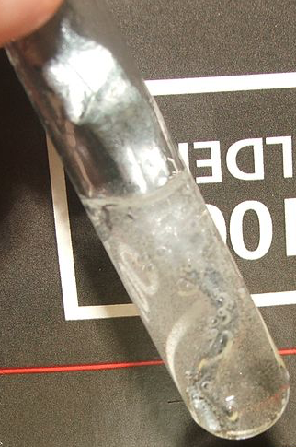
- Write a complete, balanced equation for this double displacement reaction. (Hint: The solid is a compound of Ni ² ions and hydroxide ions.) Write the complete molecular equation rather than the net ionic equation.
